1. A computer screen shot of a blue screen

   Description automatically generatedInstall **WDS**by **Powershell**
2. Create a new scope called **Win10**

1. A screenshot of a computer

   Description automatically generatedCreate a new boot called **Win10**
2. 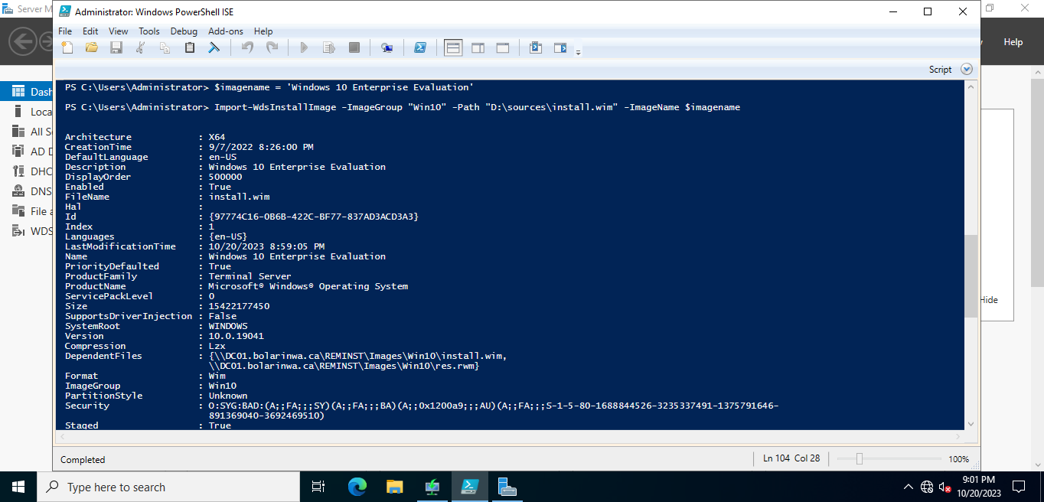**Import-wds**images **install.wim**
3. A computer screen shot of a blue screen

   Description automatically generated**import-wds**boot **boot.wim**
4. Deploy a new **Win10** over the network from WDS

Theoretical parts

1. Describe in **100**words what is the purpose of **WDS**

Windows Deployment Services (WDS) is a server role in Windows Server that facilitates the automated deployment of Windows operating systems over a network. Its primary purpose is to streamline the installation and configuration of Windows on multiple computers, making it ideal for enterprises and IT administrators. WDS enables the creation of standardized, efficient deployment processes by providing centralized management of boot and install images. This ensures faster, consistent, and scalable OS deployment, reducing manual intervention and minimizing deployment errors, ultimately enhancing productivity, and maintaining system integrity.

1. Describe in 100 words the purpose of **PXE boot**

PXE boot is a network booting protocol that allows computers to boot from a network server, rather than from local storage devices like hard drives. Its primary purpose is to simplify and expedite the deployment and maintenance of operating systems and software across multiple networked computers. PXE boot enables administrators to remotely initiate OS installations, system recovery, or disk imaging processes, eliminating the need for physical media or manual intervention. This technology is especially valuable in large-scale IT environments for efficient provisioning and updates.

1. Describe in **100**words the purpose of **unattended installation**

Unattended installation is a deployment method used to install an operating system or software on a computer without requiring constant user interaction. Its primary purpose is to streamline and automate the installation process, saving time and reducing the potential for human error. Unattended installation involves creating answer files or scripts that provide configuration settings and options, such as product keys, partitioning, and software customization. This method is particularly valuable in enterprise IT environments for deploying standardized, consistent system configurations and software installations across multiple machines, ensuring efficiency and uniformity.